



**EARTHQUAKE RESISTING BUILDING WITH RAIN WATER HARVESTING INSTALLATION**

| **SUBMITTED BY-**  MAYANK SHARMA-1801556  OPENDRA PRATAP-1801560  PRAKASH-1801562  PRASHANT PRAKASH-1801563  RAJAT UPADHYAY-1801566  RAVI KUMAR-1801567  RISHABH YADAV-1801568  RITESH JAYANT-1801569  SACHIN DHANGAR-1801571  SAURAV NIGAM-1801572  SHAHRUKH KHAN-1801574  SHIKHAR VERMA-1801575 | **SUBMITTED TO- Mrs.**KRISHMA  YADAV |
| --- | --- |

**ACKNOWLEDGEMENT**

We would like to express our heartfelt gratitude to our project guide Prof. Karishma Yadav, Assistant Professor, Civil Engineering Department, Faculty of Engineering, and D.E.I. For his painstaking and wholehearted efforts and the invaluable guidance at each stage of the development of the project. We would also like to thank the whole Civil Department for providing us with useful guidelines which helped us to direct our efforts in the right direction.

**CONTENT**

1. **ABSTRACT……………………………………………………………………………………………**
2. **WHY SHOULD WE SELECT THIS PROJECT? ………………………………………………**
3. **INTRODUCTION……………………………………………………………………………………**
4. **PRINCIPLE AND MECHANISM………………………………………………………………**
5. **COST ESTIMATIMATION………………………………………………………………………**
6. **CONCLUTION………………………………………………………………………………………**

**ABSTRACT**

This project is about the manufacturing of a earthquake resistance building with installation of rainfall harvesting installation. In this project we are trying to damp the vibration of the earthquake. This is done with the help of pendulum power suspend a large ball with steel cables with a system of hydraulics at the top of the building. When the building begins the sway, the ball acts as a pendulum and moves in the opposite direction to stabilize the direction. Like damping, these features are tuned to match and counteract the building’s frequency in the event of an earthquake.

Sometimes the earthquake is not solely responsible for the demolition of building ,a bad support structure which are not able to wear the vibration caused by earthquake.

It is also important to design a proper truss structure. 

WHY WE SHOULD DO THIS PROJECT?

There is an average of [20,000 earthquakes](https://www.usgs.gov/faqs/why-are-we-having-so-many-earthquakes-has-naturally-occurring-earthquake-activity-been?qt-news_science_products=0#qt-news_science_products) each year —16 of them being major disasters. On September 20, 2017, a magnitude 7.1 rocked Mexico’s capital city and killed approximately 230 people. As with the case with other earthquakes, the damage was not caused by the quake itself but by the collapse of buildings with people inside them, making earthquake-proof buildings a must.

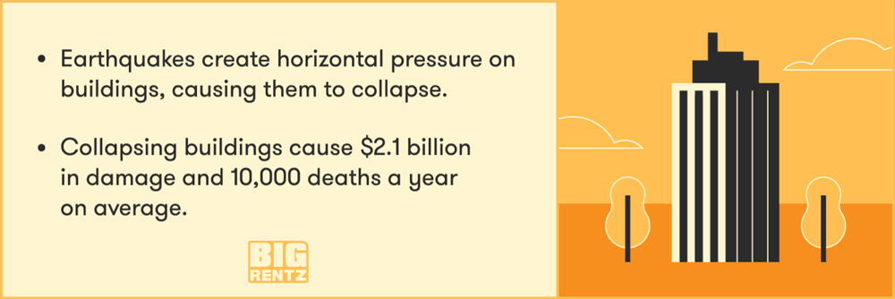

* Most of the rain falling on the surface tends to flow away rapidly, leaving very little for the recharge of groundwater. As a result, most parts of India experience lack of water even for domestic uses. Hence, the need for implementation of measures to ensure that rain falling over a region is tapped as fully as possible through rainwater harvesting, either by recharging it into the groundwater aquifers or storing it for direct use.

**INTRODUCTION**

In spite of recent developments in earthquake resistant engineering, earthquakes still inflict widespread damage in various countries. Seismic isolation is a very effective measure for protecting structures from earthquake damage

The pendulum is one of the basic methods of seismic isolation, and is also used as the basic mechanism of seismographs. However, pendulums are rarely used for seismic isolation of structures.

One advantage of the pendulum seismic isolator is that the length of the hanger L is the only parameter governing its natural period, and the mass of the object to be isolated or the tension of the hanger has no effect at all. Thus, the desired period can be obtained merely by changing the hanger length. This is the greatest advantage of the pendulum seismic isolator compared to laminated rubber bearing seismic isolators in which the natural period is determined by the mass and rigidity of the isolation structure.

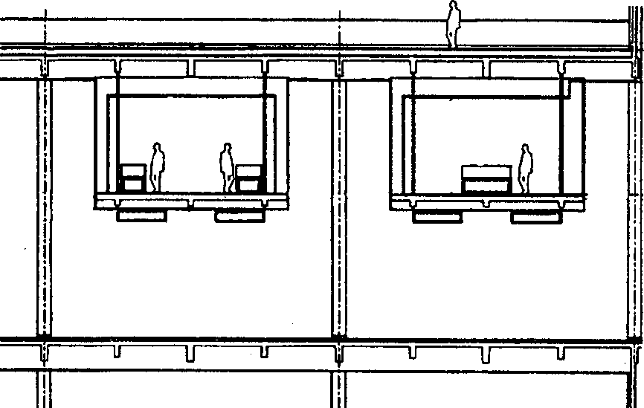

In line with the development of architectural works that are increasingly widespread and diverse in form, it requires the support of the right building structure system. The architects seem to be competing to produce very diverse works. This is a challenge for structural system experts to realize these architectural works. With the help of sophisticated computer software, and the “courage” of structural experts to “get out” of the general rules, it allows the use of structural systems that can realize the “dreams” of architects with varied building forms.

Rainwater harvesting is the process of collecting rainwater and putting it to good use. There are different ways in which this task can be accomplished. Rainwater harvesting refers to the trapping and storing of rainwater so that it can be used at a later time when the need arises. As the rain falls, water is directed to a suitable collection point.

**PRINCIPLE AND MECHANISM**

Seismic isolation is now being applied to structures with slender elevations. Although stress due to seismic motion generated in structural members is not a major issue for high-rise buildings, seismic isolation is desirable for the comfort of occupants and safety against overturning.

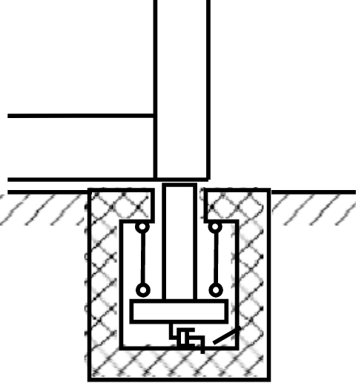

A system using the characteristics of the pendulum symmetrically hung from two supports can provide a structure with a longer natural period than the seismic isolation system with the translational pendulum. The structure supported by the pendulum symmetrically hung from two supports is, however, subject to rocking. Rocking is very detrimental to seismic isolation systems because amenity may be adversely affected or the seismic response of certain stories may not be reduced effectively. In this study, a seismic isolation system that can control rocking while using the characteristics of the pendulum symmetrically hung from two supports is discussed.

The seismic isolation system can be made by connecting the columns supported by the pendulums symmetrically hung from two supports to the superstructure by hinges. A conceptual view of the system. The columns ***Cs*** supported by the pendulums rock due to vibration, but the column tops ***E*** and ***F*** remain at the same elevation.

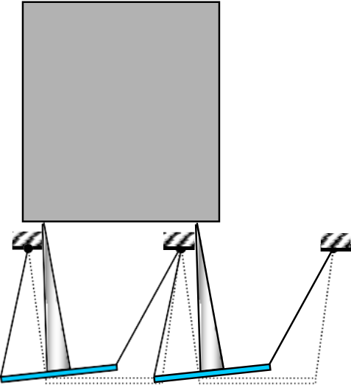

Conceptual view of application

to a seismic isolation system

The system can deal with three-dimensional movement by changing the distance of the top ends of the hangers spatially.

The effectiveness of a seismic isolation system with the pendulums symmetrically hung from four supports was examined by a vibration test using a scale model. In the test, a tower structure with an aspect ratio of approximately ten that simulated a high-rise building was adopted to facilitate testing.

The test models are composed of an upper structure and four base isolation devices. Photograph shows four base isolation devices and Photograph 2 shows the specimen on the shaking table. The superstructure was 100 cm high and 10 cm wide and was made of acrylic resin boards. The distance between the supports of the hangers was adjustable.

The upper model simulates high-rise buildings of 100 m, 200 m and 300 m height. Those simulated models produce the first mode natural periods of 2 sec,4 sec and 6 sec, respectively. To perform these simulations, the time scales for the earthquakes are compressed by scaling laws.

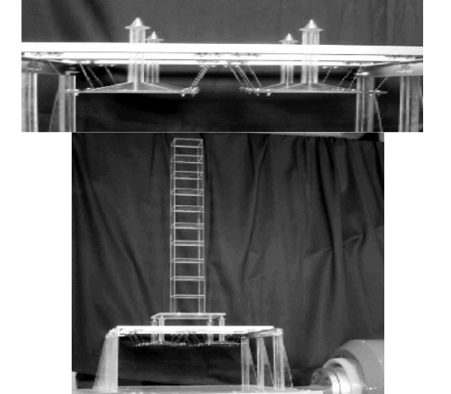

Simultaneously with the experiment, we also performed numerical analysis.

Storage of rainwater on surface for future use: The storage of rain water on surface is a traditional techniques and structures used were underground tanks, ponds, check dams, weirs etc.Recharge to ground water: the collected rainwater is transferred to the ground through suitable means for recharging the depleting aquifers

# DESIGN CONSIDERATIONS

Three most important components, which need to be evaluated for designing the rainwater harvesting structure, are:

Hydrogeology of the area including nature and extent of aquifer, soil cover, topography, depth to water levels and chemical quality of ground water

Area contributing for runoff i.e. how much area and land use pattern, whether industrial, residential or green belts and general built up pattern of the area

Hydro-meteorological characters like rainfall duration, general pattern and intensity of rainfall.

**ROOF WATER COLLECTION SYSTEMS**

In high-rise buildings, roofs can be designed for catchments purposes and the collected roof water can be kept in separate cisterns on the roofs for non-potable uses.

**FEASIBILITY OF ARTIFICIALLY RECHARGING GROUND WATER**

The feasibility of artificially recharging ground water is governed by the following factors:

Availability of suitable site, mainly from topographical and cultural considerations, for establishing recharge facilities.

Presence of suitable source to supply water of required quality in requisite quantity.

Lithological composition, thickness and permeability characteristics of rocks in the zone of aeration saturation.

Cost-benefit considerations.

**COST ESTIMATION**

| Name of the product | Cost |
| --- | --- |
| Table | 1000 |
| Steel wires | 250 |
| Iron Bars | 500 |
| Galvanized Steel Sheet | 350 |
| Total | 2100 |

**

**THANK YOU**